

CAPSTONE PROJECT REPORT
Report 2 – Project Management Plan

A2MaTeX - Android Device Automation and Distribution Platform

INSTRUCTOR: PHAM QUANG KHANG
CLASS: SEP490_G52
Team Members:
- Ly Ngoc Mai | HE190089
- Sy Thi Quynh Nga | HE190134
- Tran Tien Duc | HE180366
- Tran Xuan Dong | HE182253
- Tran Van Khuyen | HE187268

– Hanoi, Aug 2026 –

Table of Contents

Definitions & Acronyms 4
I. Record of Changes 5
II. Project Management Plan 5
- Project Overview 4
1.1 Scope and Purpose 4
1.2 Assumptions & Constraints 4
1.3 Cost & Time Estimations 4
1.4 Capacity Planning 6
1.5 Project Objectives 6
1.6 Risks and Mitigations 6
- Management Approach 7
2.1 Project Process/Methodology 7
2.2 Quality Management 7
2.3 Responsibility Assignments 7
2.4 Project Communications 8
2.5 Configuration Management 8
2.5.1 Document Management 8
2.5.2 Source Code Management 8
2.5.3 Tools & Infrastructures 8

List of Figures
Figure No. | Title | Page
Figure 1 | Development process of the iterative and incremental model | 11
Figure 2 | Team Responsibility Assignment | 14
Figure 3 | Source Code & Version Control Workflow | 18
Table 1 - List of Figures
List of Tables
Table No. | Title | Page
Table 1 | List of Figures | 3
Table 2 | List of Tables | 3
Table 3 | Definitions & Acronyms | 4
Table 4 | Record of Changes | 5
Table 5 | Assumptions & Constraints | 6
Table 6 | WBS Breakdown | 9
Table 7 | Capacity Planning | 9
Table 8 | Project Objectives | 9
Table 9 | Risks and Mitigations | 10
Table 10 | Testing Process | 13
Table 11 | Defect Classification | 13
Table 12 | Responsibility Assignment | 14
Table 13 | Project Communications | 16
Table 14 | Document Management | 17
Table 15 | Tools & Infrastructures | 18
Table 2 - List of Tables

Definitions & Acronyms
No | Acronyms & Abbreviations | Definition
1 | IDE | Integrated Development Environment
2 | API | Application Programming Interface
3 | MVP | Minimum Viable Product
4 | PMP | Project Management Plan
5 | SRS | Software Requirements Specification
6 | SDD | Software Design Document
7 | POC | Proof of Concept
8 | UAT | User Acceptance Testing
9 | UI/UX | User Interface/ User Experience
10 | WBS | Work Breakdown Structure
11 | ERD | Entity Relationship Diagram
12 | PR | Pull Request
Table 3 - Definitions & Acronyms

I. Record of Changes
Date | A*  M, D | In charge | Change Description
21/09/2026 | A | MaiLN | Added initial draft of Project Management Plan structure.
21/09/2026 | A | DucTT | Add Configuration Management Plan
22/09/2026 | A | MaiLN | Added Project Communication Plan
22/09/2026 | M | MaiLN | Modified Project Overview
*A - Added M - Modified D - Deleted
Table 4 - Record of Changes

I. Project Overview

1. Scope and Purpose
The purpose of this project is to develop A2MaTeX – Android Device Automation Development and Distribution Platform. The system is designed to provide a centralized environment for developing, managing, distributing, licensing, and executing automation applications and workflows that interact with Android devices and Android applications.
A2MaTeX allows developers to create automation solutions through the A2MaTeX IDE using a visual node-based workflow editor. Developers can combine predefined automation actions into complete workflows, test them through the IDE Runtime, and publish the resulting applications to the A2MaTeX Marketplace.
The main scope of the project includes the following components:
- A2MaTeX Marketplace: provides application browsing, application details, license purchasing, user library, and publisher management.
- A2MaTeX IDE: provides project management, code editing, visual workflow building, workflow testing, application building, and publishing.
- Desktop Client: allows users to log in, view purchased licenses, download applications, manage local packages, and run automation applications.
- Backend API: provides authentication, user management, application management, licensing, package distribution, and communication between system components.
- License Management: manages license issuance, validation, expiration, and revocation.
- Package Management: manages the creation, distribution, download, and integrity verification of app.package files.
- Runtime and Launcher: execute automation workflows and commands and manage the execution lifecycle of automation applications.
- Android Device Automation: provides automation actions that allow workflows to interact with Android devices and Android applications.
The project focuses on providing a complete platform for the development and distribution of Android automation applications. Advanced features such as enterprise-scale deployment, fully offline licensing, support for non-Android automation targets, and a large third-party plugin ecosystem are outside the scope of the current project and may be considered in future development.

2. Assumptions & Constraints
No | Description | Note
Assumptions
1 | Project documents and major deliverables are reviewed by the team and supervisor within the planned project schedule. | Project Management
2 | The main project requirements and MVP scope are agreed during the early stages. Major changes are reviewed before being added to the project. | Scope
3 | Users use the A2MaTeX Desktop Client to download and execute licensed applications. | User Environment
4 | Users must have a valid A2MaTeX account and license before licensed applications can be executed through the Desktop Client. | Business Rule
Constraints
1 | The project must be completed within approximately 14 weeks. | Schedule
2 | An application cannot be executed if its license is expired, revoked, or invalid. | Business Rule
3 | Licensed applications must be launched through the A2MaTeX Desktop Client and Launcher. Direct execution outside the Client is not supported. | Business Rule
4 | Downloaded app.package files must pass integrity verification before execution. | Security
5 | Modified, corrupted, or invalid application packages must not be executed by the Launcher. | Security
Table 5 - Assumptions & Constraints

3. Cost & Time Estimations
# | Work Package | Effort  (pds) | Due Date
1 | Stage 1: Project Initiating (week 1) | 5 | 11/09/2026
1.1 | Report 1: Project Introduction v1.0 | 5 | 11/09/2026
2 | Stage 2: Project Planning & Initial Requirements (weeks 2–3) | 29 | 25/09/2026
2.1 | Report 3: SRS v0.9 (Overall Requirements) | 10 | 25/09/2026
2.2 | Vertical Prototype (Marketplace, Client, IDE) | 12 | 25/09/2026
2.3 | Report 2: Project Management Plan v1.0 | 7 | 25/09/2026
3 | Stage 3: Software Design (weeks 4–5) | 39 | 09/10/2026
3.1 | Technical POC (Workflow Runtime, app.package, Client–API communication) | 15 | 09/10/2026
3.2 | Report 4: SDD v1.0 (High-Level Architecture & Design) | 10 | 09/10/2026
3.3 | Report 5: Test Planning (Scope, Strategy, Test Plan & Test Data) | 6 | 09/10/2026
3.4 | Report 3: SRS v1.0 (Detailed System Requirements) | 8 | 09/10/2026
4 | Stage 4: Implementation (weeks 6–11) | 132 | 20/11/2026
4.1 | Implementation Iteration 1 – Backend & Marketplace (weeks 6–7) | 42 | 23/10/2026
4.1.1 | Report 4: SDD v1.1 – Backend & Marketplace Detailed Design | 5 | 16/10/2026
4.1.2 | Code Package & Unit Testing – Auth, User, Application & Marketplace | 23 | 23/10/2026
4.1.3 | Report 5: Backend & Marketplace Integration Test Cases | 4 | 21/10/2026
4.1.4 | Report 5: Integration Test Report | 3 | 23/10/2026
4.1.5 | Report 3: SRS v1.1 – Requirements for IDE & Runtime | 3 | 23/10/2026
4.1.6 | Software Package Version 1 – Backend & Marketplace | 4 | 23/10/2026
4.2 | Implementation Iteration 2 – IDE, Workflow & Runtime (weeks 8–9) | 45 | 06/11/2026
4.2.1 | Report 4: SDD v1.2 – IDE, Workflow & Runtime Detailed Design | 5 | 30/10/2026
4.2.2 | Code Package & Unit Testing – IDE, Node Editor, Runtime & Build | 26 | 06/11/2026
4.2.3 | Report 5: IDE & Runtime Integration Test Cases | 4 | 04/11/2026
4.2.4 | Report 5: Integration Test Report | 3 | 06/11/2026
4.2.5 | Report 3: SRS v1.2 – Requirements for Client, License & Package | 3 | 06/11/2026
4.2.6 | Software Package Version 2 – IDE & Runtime Integrated Build | 4 | 06/11/2026
4.3 | Implementation Iteration 3 – Client, License, Package & Integration (weeks 10–11) | 45 | 20/11/2026
4.3.1 | Report 4: SDD v1.3 – Client, License, Package & Integration Design | 5 | 13/11/2026
4.3.2 | Code Package & Unit Testing – Client, License, Package & Launcher | 24 | 20/11/2026
4.3.3 | Report 5: End-to-End Integration Test Cases | 4 | 18/11/2026
4.3.4 | Report 5: Integration Test Report | 4 | 20/11/2026
4.3.5 | Report 5: System, Security & Runtime Test Cases | 4 | 20/11/2026
4.3.6 | Software Package Version 3 – Integrated Release Candidate | 4 | 20/11/2026
5 | Stage 5: Verification & Validation (weeks 12–13) | 38 | 04/12/2026
5.1 | Report 5: System, Security & Regression Test Report | 12 | 27/11/2026
5.2 | Report 5: UAT / Acceptance Test Support | 10 | 04/12/2026
5.3 | Report 6: User Guides (Marketplace, Desktop Client, IDE & Installation) | 8 | 04/12/2026
5.4 | Final Software Package (Source Code, Installers, Documents & Deployment) | 8 | 04/12/2026
6 | Stage 6: Project Closing (week 14) | 18 | 11/12/2026
6.1 | Report 7: Final Project Report | 12 | 11/12/2026
6.2 | Final Presentation & Demo Package | 6 | 11/12/2026
Total Estimated Effort (man-days) |  | 261
Table 6 - WBS Breakdown

4. Capacity Planning
Item | Value
Hours per person per week | 40 h (8 h/day × 5 days)
Team total per week | 5 × 40 = 200 h/week
Total duration | 14 weeks
Gross capacity | 200 × 14 = 2,800 h
Buffer (meetings, reviews, unplanned — [20]%) | 2,800 × 20% = 560 h
Effective working capacity | 2,800 × 80% = 2,240 h
Table 7 - Capacity Planning

5. Project Objectives
# | Metric | Unit | Planned | Actual | Notes / References
1 | Effort Usage | Person-days | 261 | N/A | Keep total effort within the effective capacity of 280 person-days.
2 | Reviewing | No. of major defects | ≤10 | N/A | Review PMP, SRS, SDD, Test Document, User Guides and related design artifacts.
3 | Unit Test | No. of major defects | ≤10 | N/A | Verify Backend APIs, Marketplace, IDE workflow, Runtime, Client, License and Package modules.
4 | Integration Test | No. of major defects | ≤15 | N/A | Test IDE → Marketplace → License → Client → Launcher → Runtime integration.
5 | System Test | No. of major defects | ≤20 | N/A | Cover Build, Publish, Purchase, Download, License Validation, Package Verification and Run flows.
6 | Acceptance Test | No. of major defects | ≤10 | N/A | Validate Buyer, Publisher and Admin workflows before final release and handover.
7 | Timeliness | % |  |  | Total on-time deliverables / Total project deliverables
8 | Requirement Completeness | % |  |  | Failed if <=75%
Table 8 - Project Objectives

6. Risks and Mitigations
# | Risk | Prob | Impact | Mitigation
R01 | Requirements or project scope change significantly during development. | Medium | High | Baseline requirements and MVP scope in Iteration 1. New requests require impact analysis; non-critical changes are moved to post-MVP.
R02 | Limited availability or unexpected absence of part-time members. | Medium | High | Define backup ownership in Iteration 1; maintain shared docs/code reviews from Iteration 2; redistribute critical tasks at each iteration planning.
R03 | Integration between IDE, Marketplace, License, Client, Launcher, and Runtime is delayed or fails. | High | High | Define API/data contracts in Iteration 1–2; start integration in Iteration 3; complete the end-to-end Build → Publish → Purchase → Download → Run flow in Iteration 4.
R04 | Security vulnerabilities in authentication, license validation, package download, or application execution. | Medium | High | Apply authentication/RBAC and secure API access in Iteration 2–3; add package integrity and license validation controls; perform security and negative testing in Iteration 4.
R05 | Runtime, Launcher, or app.package fails with different workflows, .exe files, or Windows environments. | Medium | High | Define supported environments in Iteration 2; implement logging, timeout, error handling, and package verification in Iteration 3; run compatibility and regression tests in Iteration 4–5.
Table 9 - Risks and Mitigations

II. Management Approach

1. Project Process/Methodology
In this project, we apply the Iterative and Incremental development model. The main principle of this model is to develop the system through a number of iterations, where each iteration follows the main phases: Requirement Analysis → Design → Coding → Testing.
With this approach, our A2MaTeX - Android Device Automation and Distribution Platform is gradually developed and improved through multiple iterations. Lessons learned and feedback from earlier iterations are incorporated into later ones, ensuring continuous improvement and higher quality of the final product.
Each implementation iteration delivers a working subset of the system, for example:
- Iteration 1 focuses on the core Backend and Marketplace, including authentication, user management, application management, and basic marketplace functions.
- Iteration 2 focuses on the Custom IDE, Workflow Builder, Runtime Engine, and the build process for creating app.package.
- Iteration 3 focuses on the Desktop Client, License Management, Package Management, Launcher, and integration between all major modules.
After the implementation iterations, the team performs full system integration and verifies the main end-to-end flow:
Create → Build → Publish → Purchase → Download → Validate License → Run
This approach allows the team to validate important features early, handle requirement changes more easily, reduce integration risks, and gradually deliver a complete and stable system.
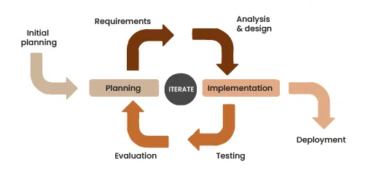
Figure 1: Development process of the iterative and incremental model

2. Quality Management

2.1 Defect Prevention
- Any defect found during Requirement, Design, Coding, or Testing must be reported to the responsible member as soon as possible.
- Defects are evaluated based on severity and impact, especially whether they affect critical flows such as license validation, package download, workflow execution, or Android device automation.
- Each defect must have a clear owner and resolution deadline.
- Requirement reviews, design reviews, code reviews, and unit tests are used to prevent defects early.
- API contracts, package rules, and runtime behavior are defined before implementation to reduce integration issues.

2.2 Coding
- Each developer is responsible for testing their implemented features.
- Pull Requests must be reviewed before merging.
- Team members regularly synchronize branches to reduce conflicts.
- Sensitive information (API keys, passwords, tokens) must not be committed to source control.
- Security, error handling, and logging are required for important backend, license, package, runtime, and launcher functions.

2.3 Reviewing
- Reviews must remain objective, focusing solely on code or documentation quality, not personal bias.
- Findings (defects, gaps, ambiguities) are logged in GitHub Project with severity, priority, and owner details.
- Assigned members are responsible for promptly addressing review findings and confirming fixes.
- Major artifacts subject to review: Software Requirement Specification (SRS), Software Design Specification (SDS), Project Management Plan (PMP), UI/UX wireframes.

2.4 Unit Testing
- Unit testing is performed for all important modules such as Authentication, User, Application, License, Package, Workflow, Runtime, and Launcher.
- Test cases must be carefully designed to cover normal, boundary, and exceptional cases.
- Results and discovered defects are logged with priority in the GitHub Project.
- The developer responsible must resolve unit test defects immediately.

2.5 Integration Testing
- Integration testing verifies communication between the major A2MaTeX components.
- The full Build → Publish → Purchase → Download → Validate License → Run flow is tested before system testing.
- Defects found are logged with priority; responsible members must address them quickly.
- Iterations include dedicated integration checkpoints to ensure modules work smoothly together.

2.6 System Testing
- System testing verifies the complete A2MaTeX platform against the SRS.
- Testing covers Marketplace, IDE, Client, Backend, License, Package, Runtime, Launcher, and Android automation.
- System testing also validates compliance with performance, privacy, and security requirements.
- Defects are logged in GitHub Project, prioritized, and resolved before moving to UAT.
- System testing ensures the solution can operate in real-world environments with multiple concurrent users and diverse device types.

Testing Method | Target
Unit Test | Validate critical modules independently, including Authentication, License, Package, Workflow, Runtime, and Launcher; ensure ≥ 95% coverage for core business logic.
Integration Test | Verify data and control flows across IDE ↔ Backend ↔ Marketplace ↔ Client ↔ License ↔ Launcher ↔ Runtime and detect interface or data inconsistencies.
System Test | Execute major user flows such as create workflow, build, publish, purchase license, download package, validate license, and run automation; confirm functional and non-functional requirements are satisfied.
Performance Test | Evaluate API response time, Marketplace loading, package download, and Runtime execution under expected concurrent usage; identify performance bottlenecks before release.
Security Test | Verify authentication, authorization, license validation, protected API access, and app.package integrity; ensure unauthorized users cannot access or execute protected applications.
Usability Test | Observe representative users using the Marketplace, Desktop Client, and IDE; collect feedback to improve UI/UX and workflow clarity before final acceptance.
Regression Test | Re-test critical functions after bug fixes or major changes to ensure existing features are not affected.
Acceptance Test | Validate the complete Create → Build → Publish → Purchase → Download → Validate → Run flow with target users before final delivery.
Table 10 - Testing Process

Defect Label | Description | Action
CRITICAL | Blocks core system operation or causes serious security/data issues (e.g., license bypass, app crash, package execution failure). | Stop all new feature development; assign top priority and fix immediately.
MAJOR | Severely impacts key flows (e.g., publish failure, download failure, invalid license status, runtime error) | Block release until resolved; address within the current iteration.
MINOR | Affects non-critical functions or user experience (e.g., incorrect message, minor UI issue, logging problem) | Record and fix based on priority.
TRIVIAL | Cosmetic or documentation issue with little system impact (e.g., typo, alignment issue, minor display inconsistency) | Defer to future maintenance; record for reference but no immediate fix required.
Table 11 - Defect Classification

3. Responsibility Assignments

3.1 Teams and Structures

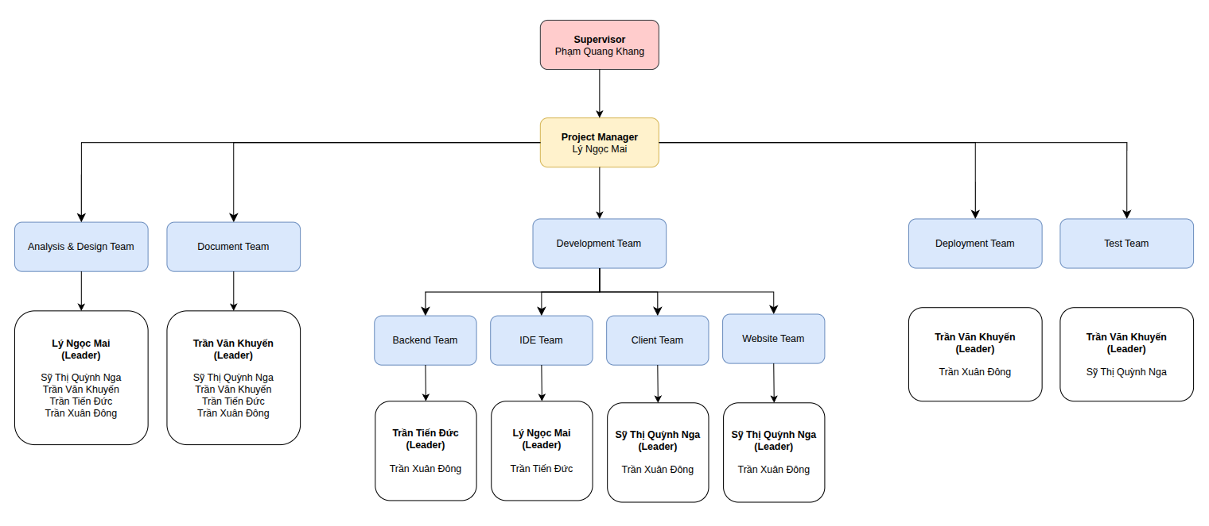
Figure 2: Team Responsibility Assignment

3.2 Responsibility Assignment
The table below lists the responsibilities of a person in a specific role. Each role carries different
responsibilities related to the team and the assignment tasks.

RACI Chart: R~Responsible, A~Accountable, C~Consulted, I~Informed

# | Work Package | MaiLN | NgaSTQ | KhuyenTV | DucTT | DongTX
I. Planning
1 | Define project scope & MVP | R | C | C | I | I
2 | Create project schedule & process | R | C | C | I | I
3 | Select technology & architecture | A | C | I | R | R
II. Requirements & Design
4 | Requirement analysis & use cases | C | R | R | C | C
5 | Design system architecture | C | I | C | A | R
6 | Design database & API contracts | I | C | C | R | R
7 | Design IDE & Workflow UI/UX | R | C | C | C | I
8 | Design Marketplace & Client UI/UX | C | R | C | I | I
III. Documentation
9 | Report 1: Project Introduction | A | C | R | I | I
10 | Report 2: Project Management Plan | R | I | A | I | I
11 | Report 3: Software Requirements | A | R | R | C | C
12 | Report 4: Software Design | A | C | C | R | R
13 | User guides & API documentation | A | R | R | C | C
IV. Development
14 | Implement Backend modules (Auth, User, App, License) | I | C | I | R | R
15 | Implement Marketplace Web | C | R | C | I | C
16 | Implement Desktop Client | C | R | C | I | R
17 | Implement IDE & Workflow Editor | R | I | C | R | I
18 | Implement Workflow Runtime & Build | C | I | C | R | C
19 | Implement Package & Launcher | I | C | C | R | R
20 | Implement Publish to Marketplace | A | C | C | R | R
V. Testing
21 | Test planning (unit, integration, system, UAT) | C | R | R | C | C
22 | Unit testing | C | R | C | R | R
23 | Integration testing | C | C | A | R | R
24 | System & Security testing | C | C | A | R | R
25 | Usability & acceptance testing | A | R | R | I | I
VI. Deployment & Handover
26 | Deploy Backend & Marketplace | I | C | I | R | R
27 | MVP release & feedback collection | A | R | R | C | C
28 | Final release, documentation handover & archive | A | R | R | C | C
Table 12 - Responsibility Assignment

4. Project Communications
Communication Item | Who/ Target | Purpose | When, Frequency | Type, Tool, Method(s)
Daily Meeting | All team members | Share progress, clarify tasks, raise blockers. | Every workday at 22:00 | Google Meet (20 min)
Weekly Supervisor Meeting | Team members & Instructor | Review overall progress, discuss issues, obtain feedback. | Every Thursday at 12:50, once every two weeks | In-class or Google Meet
Iteration Planning Meeting | All team members | Plan upcoming iteration based on WBS deliverables, assign responsibilities. | At the beginning of each iteration | Google Meet, Google Sheets
Iteration Review Meeting | All team members | Review completed features and documents, demonstrate the system, and evaluate whether iteration objectives are achieved. | At the end of each iteration | Google Meet, Google Sheets
Urgent Communication | Relevant team members | Resolve critical blockers, build failures, deployment issues, or problems affecting other team members. | As needed | Messenger group chat, direct call
Table 13 - Project Communications

5. Configuration Management

5.1 Document Management
Our team uses Google Drive to store, organize, and manage all project documents. Google Drive allows team members to access shared files, work on the same documents at the same time, and keep track of document changes through version history.
The project documents are organized into several main folders based on their purposes. The Documents folder contains official project reports such as Project Introduction, Project Management Plan, Software Requirements Specification, Software Design Description, Software Testing Document, User Guide, and Final Project Report. The Management folder contains project tracking files, weekly reports, task assignments, meeting notes, and project planning materials. The Testing folder is used to store test cases, defect reports, test results, and other testing-related documents.
Most reports are written using Google Docs, while project tracking, weekly reports, schedules, and issue tracking are managed using Google Sheets. These tools allow all team members to collaborate and keep project information synchronized.
Google Drive version history is used to track changes made to project documents. Important documents are also maintained with a change log to record major updates during each project iteration.
Link to Drive:
No | Definition
Google Drive | Store and organize all project documents
Google Docs | Project reports, specifications, User Guide, Final Report
Google Sheets | Project Tracking, Weekly Reports, WBS, Schedule, Issues and Defects
Canva | Slide presentations
Stitch | Design UI components and application screens
Draw.io, Mermaid | System diagrams, architecture diagrams, ERD, use case and sequence diagrams
Table 14 - Document Management

5.2 Source Code Management
Team members use GitHub for source code and version control following this workflow:
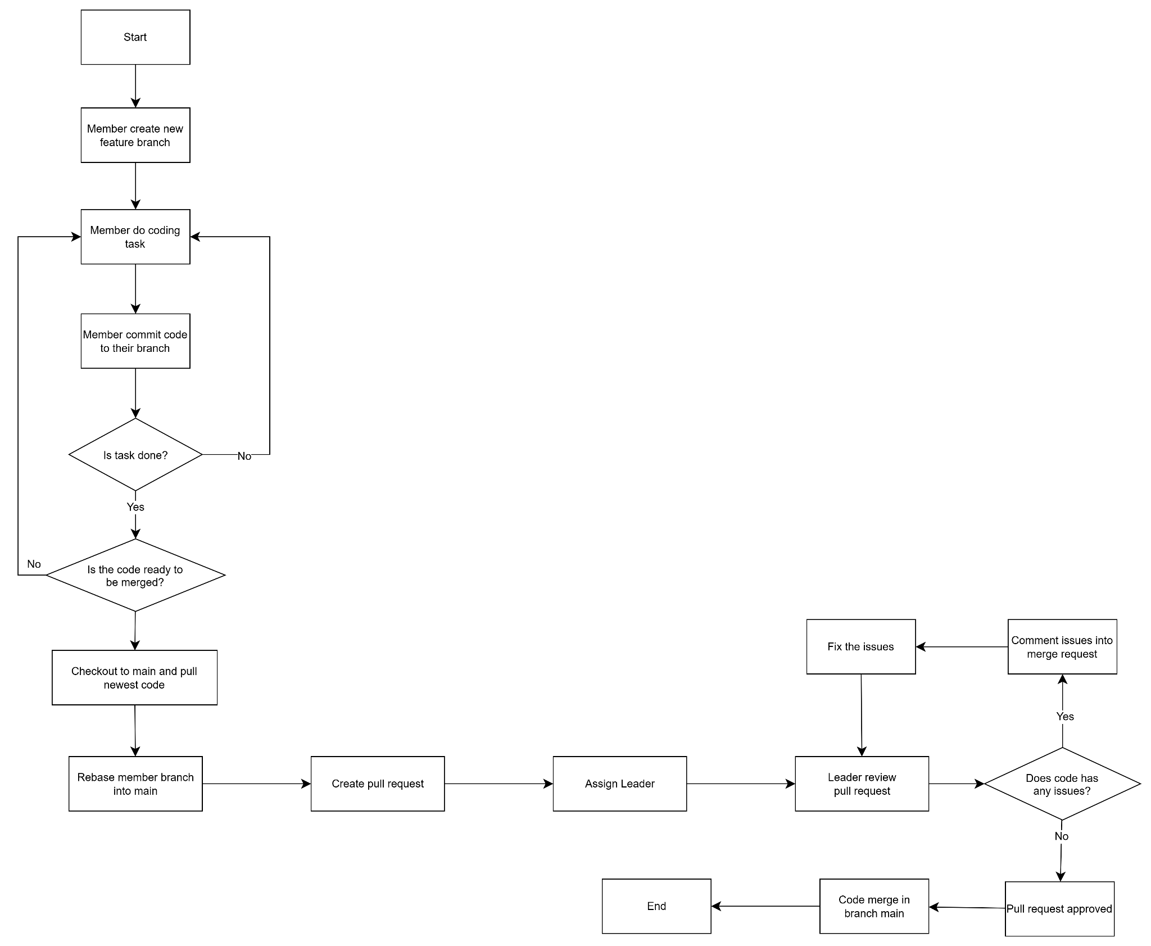

Figure 3: Source Code & Version Control Workflow

5.2.1. Convention
- All team members must work on a dedicated feature, bugfix, or task branch. Direct development on the production branch is not allowed.
- All changes must be committed and pushed to the remote repository before a PR is created.
- Before creating a PR, the developer must test the changes locally and ensure that the implementation works as expected without introducing known issues.
- Every Pull Request must be reviewed and approved by the Team Leader of the corresponding team before it can be merged into the staging branch.
- The staging branch can only be merged into the production branch in 2 cases:
  - Scheduled Feature Releases: Upon thorough testing and approval of a set of integrated modules on the staging branch, representing a completed release package for end users.
  - Emergency Hotfixes: To resolve critical production defects requiring immediate remediation; minor defects shall be addressed in staging and deployed during the subsequent standard release cycle.
- The production branch must contain only reviewed, tested, approved, and stable code.

5.2.2. Management
- Source code managed by GitHub.
- The technical leader is the person who must review carefully before merging the code of team members.
- Only team members and mentors can access the repository on GitHub. A2MaTeX - Project

5.3 Tools & Infrastructures
Category | Tools / Infrastructure
Technology | ReactJS (FrontEnd), Flutter (Desktop App), ElectronJS (Custom IDE), NestJS (BackEnd)
Database | PostgreSQL, Redis
IDEs/Editors | Antigravity, Datagrip
Diagramming | DrawIO, Mermaid
Documentation | Google Docs/Sheets
Version Control | Github (Source Codes), Google Drive (Documents)
Deployment server | Google Cloud Service
Project management | Google Sheets (Schedule, Tasks, Defects), Github (Review Pull request, Issue Management)
Table 15 - Tools & Infrastructures

